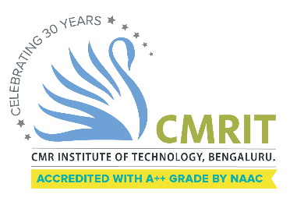
CMR INSTITUTE OF TECHNOLOGY
ACADEMIC YEAR 2025-2026
Video Session REPORT
DEPARTMENT OF INFORMATION SCIENCE AND ENGINEERING

Subject code | BIS613D | Course Name | Cloud Computing and Security
Semester / Section | 6 A, 6 B & 6 C | Prepared By | Dr Senthil Velan S  Dr Srividya R  Ms Sneha P
Curriculum Gap Identified: | Need to introduce vital concepts that was imbibed to the students using alternative methods of demonstration using video sessions. Several videos were shown in the class but only the most important of them are listed below.

Summary of Video Sessions Conducted:
Sl No. | Topic | Date | Duration | Total number of students
1 | Creating VM in Windows OS | 10.02.26 | 4:53 Minutes Video, 40 Minutes discussion | Sec A –  Sec B –  Sec C –
2 | Azure Fundamentals | 10.03.26 | 5:11 Minutes Video, 40 Minutes discussion | Sec A –  Sec B –  Sec C –
2 | Google App Engine | 07.04.26 | 4:24 Minutes Video, 40 Minutes discussion | Sec A –  Sec B –  Sec C –

Detailed Report
1 | Topic: Creating VM in Windows OS | Date:  10.02.26 | Duration:  4:53 Minutes Video, 40 Minutes discussion | Sec A –  Sec B –  Sec C –
https://www.youtube.com/watch?v=WWzMrtj2Or8

2 | Topic: Azure Fundamentals | Date: 10.03.26 | Duration:  6:40 Minutes Video, 40 Minutes discussion | Sec A –  Sec B –  Sec C –
https://www.youtube.com/watch?v=YfZ0zk5Zzcw

3 | Topic:  Google App Engine | Date: 07.04.26 | Duration:  4:24 Minutes Video, 40 Minutes discussion | Sec A –  Sec B –  Sec C –
https://www.youtube.com/watch?v=2lhOEO-zmjw

