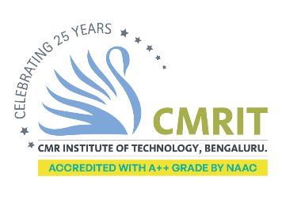
CMR INSTITUTE OF TECHNOLOGY ACADEMIC YEAR 2025-26
Video Session REPORT-Plan
DEPARTMENT OF INFORMATION SCIENCE AND ENGINEERING
Subject code | BIS402 | Course Name | Advanced JAVA
Semester / Section | ISE 4 A, B, C | Prepared By | Dr. S. Seetha
Curriculum Gap Identified: | Syllabus is fine

Summary of Video Sessions conducted:
Sl No. | Topic | Date | Duration | Total number of students
1 | Applications of Servlet | 29th May 2026 | 45 MINS
2 | Applications of JSP | 30st May 2026 | 45 MINS
3 | Applications of JDBC | 31st May 2026 | 45 MINS

