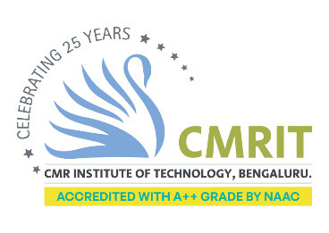

CMR INSTITUTE OF TECHNOLOGY ACADEMIC YEAR 2025-2026
Flipped Classroom REPORT – Plan
DEPARTMENT OF INFORMATION SCIENCE AND ENGINEERING

Subject code | BIS402 | Course Name | ADVANCED JAVA
Semester / Section | ISE 4 A, B, C | Prepared By | Dr. S. Seetha
Curriculum Gap Identified: | NIL

Summary of Flipped Classes conducted:
Sl No. | Topic | Date | Flipped class / Video Session(Choose from dropdown) | Total number of students
1 | Swing’s JTextField | April 15th 2026 | Flipping the teacher
2 | Swing’s JButton | April 16th 2026 | Flipping the teacher
3 | Swing’s  JRadio Button | April 17th 2026 | Flipping the teacher

