BIOLOGY FOR COMPUTER ENGINEERS- BBOC407

MODULE 1

Module 1
CELL BASIC UNIT OF LIFE

Introduction. Structure and functions of a cell. Stem cells and their application.

Biomolecules: Properties and functions of Carbohydrates, Nucleic acids, proteins, lipids.

Importance of special biomolecules: Properties and functions of enzymes, vitamins and hormones.

https://nptel.ac.in/courses/121106008

Introduction

WHY BIOLOGY ?

- … offering interdisciplinary perspectives and potential applications in areas such as bioinformatics, computational biology and medical technology.

- It enhances the student's ability to integrate biological concepts into computer science advancements.

- It is well known that this is the century of biology in which significant advances in the understanding and application of biological systems are expected.
- The significant impact on the world is expected in terms of better healthcare, better processes, better products and an overall better quality of life.
- Thus, any person can be interested in knowing the fundamentals of biology to be able to understand, or participate in the biological revolution.
- For example, any engineer, irrespective of the parent discipline (mechanical, electrical, civil, chemical, metallurgical, etc.,) has a high probability of using the disciplinary skills toward designing/improving biological systems in the future.

CELL:

- It is the fundamental unit of life.
- It represents the smallest structural and functional entity of a living organism.

CELL FORMATION:

Life originated from creation of cells, their complexity and organization. So the process and formation of cell can be categorized as FOLLOWING:

- Prokaryotic : they lack a true nucleus. Ex- BACTERIA

- Eukaryotic : they have a true nucleus and membranes surround the organs inside the cell. Ex- FOUND IN PLANTS ANIMALS, FUNGI.

Summarizing: Cell formation is the first stage of life., with nucleus and other organelle’s.

CELL DIVISION:

- Cells have the ability to divide (multiply), through the process of mitosis (eukaryotic) or meiosis.

- This division is very essential for growth, development and maintenance of living organisms.

MULTICELLULARITY:

- Over time, cells multiply, and give rise to multicellular structure.

- They further form specialized cell types, which will have distinctive function

- They also give rise to tissues, organs, and organ systems.

DIFFERENTIATION :

- Cells within Multicellular organisms undergo a differentiation process.

- i.e., they undergo their own special changes to acquire special structure based on their own requirements, functions and environmental conditions .

- This enables the cells to perform specific tasks within the organism.

ORGANISM FORMATION :

- Combination of specialized cells or tissues or multicellular structure or organs, results in the formation of a complete organism.

- Organisms can range from simple to complex

- Organisms emerged based on organization and coordination of cells.

REPRODUCTION :

- Organisms reproduce to pass their genetic information like memory, physical characteristics and other features.

- Types of reproduction: sexual/asexual.

ADAPTATION AND EVOLUTION :

- Over generations living organisms undergo adaptation and evolution.

- New species of animals or animal kingdom may evolve based on requirements or environmental conditions.

- Genetic material within the cell can change through mutation and based on natural selection leading to development of diverse species.

ECOLOGICAL INTERACTIONS :

- Organisms interact with the environment and with each other in a complex ecosystem.

- These interactions contribute to the balance of life and sustainability of the ecosystem.

Introduction to Cell Structure

- Cells are the basic units of life …They are Classified as prokaryotic and eukaryotic cells (membrane bound cells).

- Cell Components

• Cell Membrane : It surrounds the cell.
It regulates entry and exit of any substance.
It is semi permeable, water and air can pass through it.
It acts as a protective cover.

• Nucleus (present in Eukaryotic Cells) : It contains genetic material like DNA.
Its known as “brain” of a cell since it controls all activities of the cell.

• Cytoplasm : It is a gel-like substance present inside the cell membrane.
It has organelles and it helps them to float and also holds them.

• Organelles : They are specialized structure, with specific functions
Example- Mitochondria produces energy in a cell.

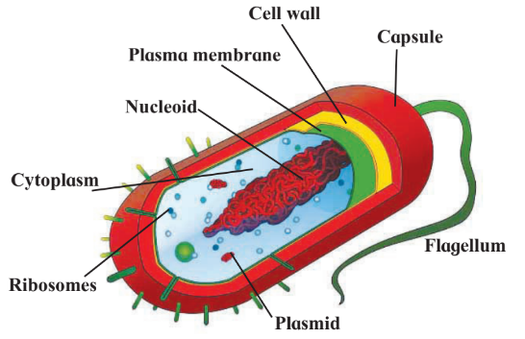
Fig 1. Schematic of A Prokaryotic Cell

- As in figure 1, cells do not have well defined nucleus but only nucleoid is present, and look like bacteria with long tails and shape.
- Cytoplasm , Cell wall and cell membrane present.
- Capsule like Nucleoid are present.
- Organelles like Plasmid, Ribosomes are present.

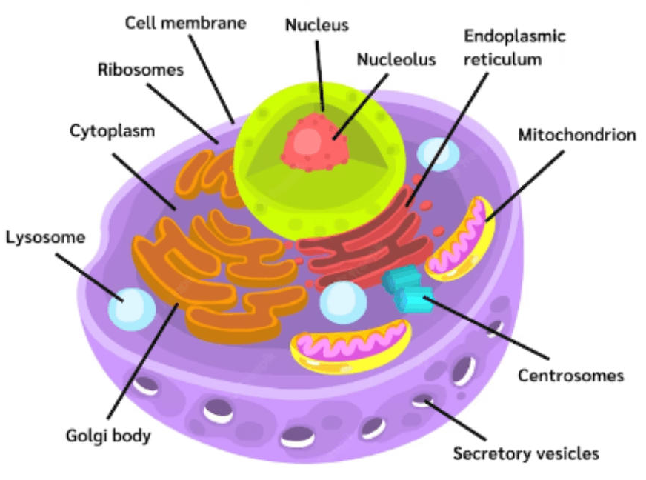

Fig 2. Schematic of A Eukaryotic Cell

- As shown in figure 2, cells have a well defined nucleus and have complex structure.
- It's slightly oval in shape.
- It has Ribosomes, Endoplasmic reticulum, Mitochondrion, Centrosomes, Golgi body, Lysosome.

Functions of a cell.

- Cellular Respiration :

- Means generation of energy.
- The Mitochondria generates energy in the form of Adenosine Triphosphate (ATP), through cellular respiration.
- It is a process of producing energy by cell.

- Photosynthesis (in Plant Cells) :

- Process of generating food by cells present in plant leaves.
- Plants absorb water from soil using roots, which gets transferred to leaves.
- Leaves contain specialized cells called CHLOROPLAST that convert sunlight into glucose.

- DNA Replication and Cell Division :

- The Nucleus (Eukaryotic) having DNA has this process.
- DNA produces a single strand that will grow into a double strand and replicates it.
- Replication and division of cells is controlled by cells for the purpose of growth in animals.

- Protein Synthesis :

- Ribosomes synthesize proteins using the feed (genetic information) given by the nucleus.
- Proteins are generated in cells and are very essential for any animal.
- Type of protein to be generated in a cell is decided by genetic information or DNA.
- Based on requirement proteins are synthesized or supplied.

STEM CELLS and their Application
.

Introduction to Stem Cell

- Stem cells are unique cells.
- They have the ability to develop into various specialized cell types (cells in heart, kidney, eyes are all different)…
- They play a very crucial role in growth, mainly tissue repair.

Types

- Embryonic Stem Cells

- These are derived from embryos.
- They have the potential to become any body cells and forms.
- For example, these cells can become heart cells and tissues or they can become kidney cells and so on.
- After fertilization, within 3 days the healthy embryo is formed and it will contain upto 6 to 10 embryo cells as in figure 3.

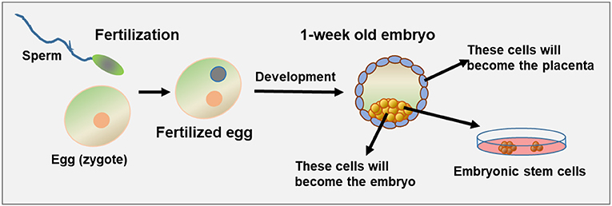
Figure 3. Embryonic Stem Cells

- Within a week a fertilized egg is formed and it's called Blastocyst.
- From embryo, cells are separated and stored, for research purposes.

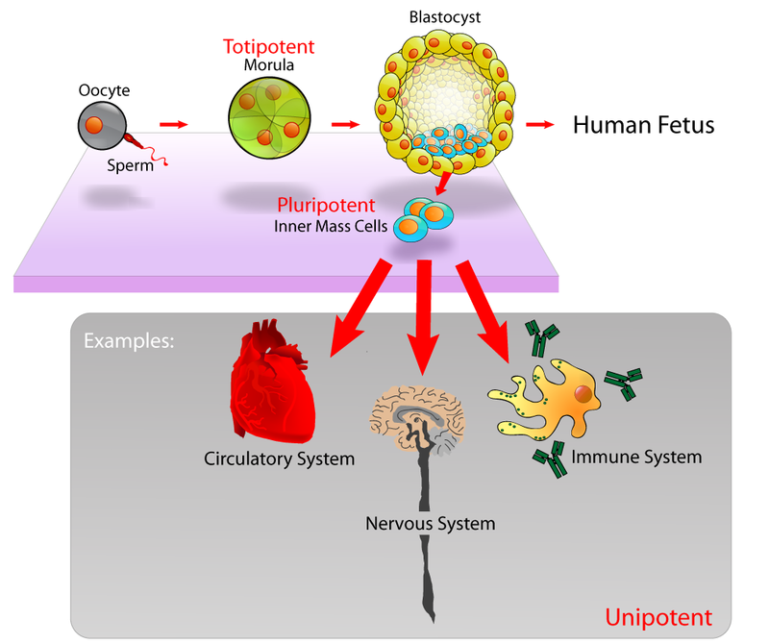
Figure 4. Examples of Embryonic Stem Cells

- Adult or Somatic Stem Cells

- These cells are found in various tissues.
- These cells are obtained from specialized organelles and are adult/ grown up cells.
- If cells are taken from the brain, then they become Brain Somatic stem cells, if taken from heart, they become heart somatic stem cells.
- Each cell performs their particular role.
- They can be used to replace damaged cells in organs accordingly.

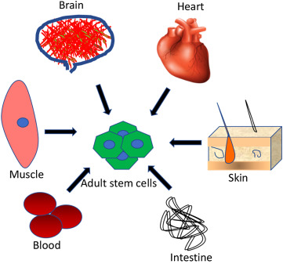
Figure 5. Somatic Stem Cells
Applications

- Regenerative Medicine : Stem cells are used to regenerate damaged tissues & organs.
- Tissue Repair
- Orthopedic Treatments : Joint and bone regeneration

- Treatment of Diseases
- Blood Disorders : treating Anaemia, leukemia by replacing blood cells.
- Neurological Disorders : In Parkinson and Alzheimer diseases.

- Drug Development and Testing : For testing new drugs before using them on animals.

- Understanding Disease Mechanisms : In labs and controlled manner, diseases and their spread and control, can be studied using stem cells.

- Cell-Based Therapies : To address various medical conditions and treating a particular malignant cell to stop spreading of disease.

- Personalized Medicine : Tailoring treatments based on personalized traits and genetics and characteristics.

Challenges

- Controlling Cell Differentiation : ensure precise control of differentiation of stem cells into specific stem cells.

- Genetic Stability : Maintaining stability during their growth, so that mutation / abnormalities do not happen.

- Tumor Formation : Potential of stem cells to form tumors to be addressed.

- Immunological Rejection : In some treatments body may not accept stem cells injected in / may be bio incompatible, this called immunology rejection.

Ethical Considerations

- Source of Stem Cells :

- The concern here is in using the embryonic cell. It involves disturbing the embryo.
- There are many debates happening on the sanctity of human life.
- The challenge here is, in balancing, scientific progress with ethical concerns.

- Informed Consent :

- The source of the embryo is a concern as it is only a few cells.
- Bio technologist has to take consent before taking the Stem cells for research and treatment

- Global Regulations :

- There are different rules and regulations in different countries.
- Universal guidelines are required in this area of study.

- Commercialization and Access :
- Making the therapy as a business, affordability becomes a major challenge for the general population.
- It is a concern, so the government should ensure fairness here.

Biomolecules:

Introduction to Biomolecules:

- Biomolecules are the building blocks of life.
- They play very crucial roles in the structure and functioning of living organisms.

Key Bio molecules are as follows:

- Carbohydrates :

- They play a very crucial role as fuel supply, supporting growth and facilitating energy release.

- Nucleic Acids :

- They are fundamentals for inheritance, animal character, nature, behaviour, and are similar to their ancestors.
- These are responsible for Good/Bad things and genetic diversity.
- DNA & RNA are used to synthesize proteins that are essential for the life process.

- Proteins :

- They Contribute to regulation of biological processes forming the cellular structure.
- They catalyse many chemical reactions happening in our body, for growth and other purposes.
- They speed up biological reactions.

- Lipids :

- These are needed for maintaining cell integrity / shape.
- Provide protective barrier acting as a membrane
- Serve as a reserve energy source.

CARBOHYDRATES

- These are classes of organic compounds.

- They play a crucial role in biology and are important energy sources.

- They are composed of carbon (C), hydrogen (H), and oxygen (O) atoms and are classified based on their molecular structure and function.

- General formula is C_{n}(H₂O)_{n}

- Simple Carbohydrates obey this formula whereas complex carbohydrates do not obey this formula.

- They are classified as follows:
- Monosaccharides
- Disaccharides
- Polysaccharides

Monosaccharides :

- Simple form of Carbohydrates and are water soluble.

- Having a single structure and serve as the primary source of energy.

- Carbon having double bond with Oxygen or with single bond

- Example: - Glucose, Fructose.

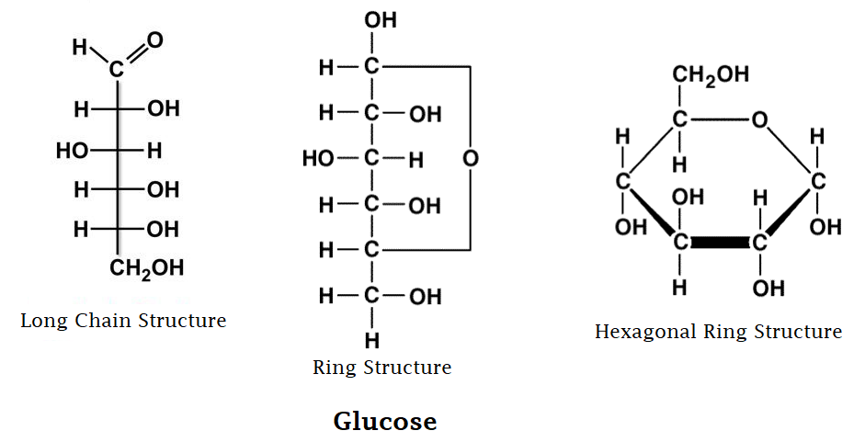
Figure 6. Glucose
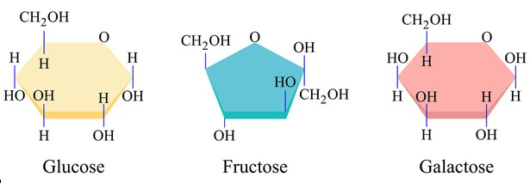
Figure 7. Glucose, Fructose & Galactose

Disaccharides :

- Two monosaccharides combined becomes Disaccharides

- They are formed by condensation of 2 monosaccharides

- They are commonly found in Sugar and broken down into monosaccharides.

- Example: Sucrose, Lactose, Maltose

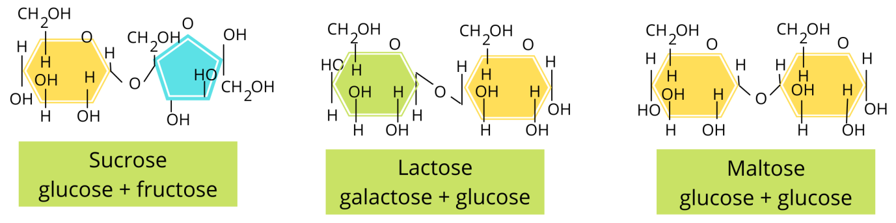
Figure 8. Sucrose, Lactose & Maltose

Polysaccharides :

- Poly means “many”.

- Many such saccharides are combined.

- These are long chain monosaccharides that are linked together.

- Storage molecules of energy.

- Example: Glycogen in animals, Starch in plants.

- Cellulose in plants play an important role as cellular processors i.e, cellular processes [ signaling, recognition ( identifying things ), and in reflecting gene expressions ]

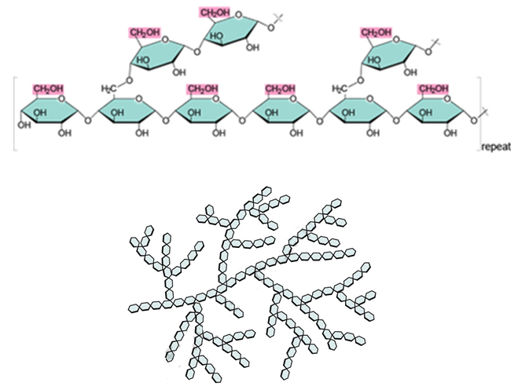
Figure 9. Glycogen
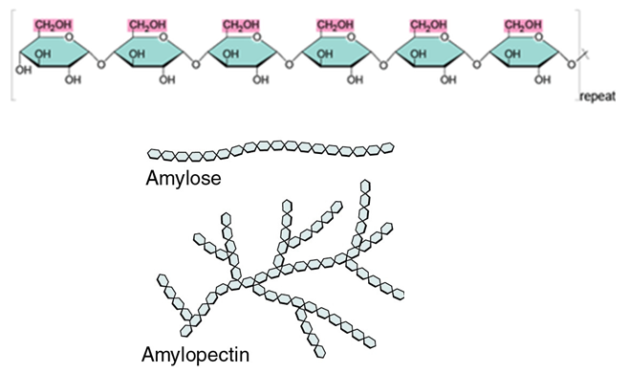
Figure 10. Starch

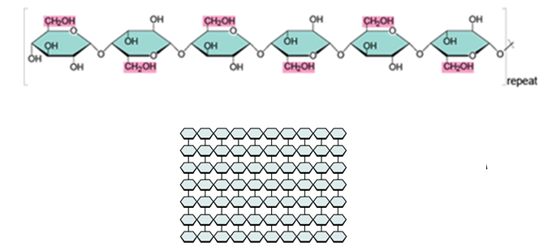

Figure 11. Cellulose

NUCLEIC ACIDS:

- They are long chain biological polymers.
- Same Molecules are repeated many times in sequence.
- It is used for storage and transfer of genetic information.
- Artificial Nucleic Acids are also synthesized now-a-days.

- Types: DeoxyRibonucleic Acid (DNA) and Ribonucleic Acid (RNA).
- Both are used for processes like replication, Transcription , Translation of genetic information.

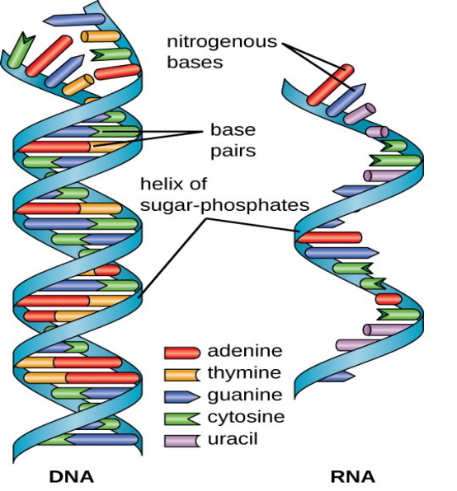
Figure 12. DNA and RNA Schematic representation.
DNA:
- DNA information is for development, functioning and for reproduction.
- It is actually a double stranded helical structure.
- It consists of sugar molecules, phosphates, and Nitrogen bases like Adenine, Guanine, Cytosine and Thymine.

RNA:

- It involves expression of genetic information stored in DNA by carrying the message from DNA to RNA.
- Used to duplicate the genetic information by separating 1 strand from DNA, and this strand is called messenger RNA(mRNA).
- mRNA carries the information of various nucleotides and their sequence.
- The mRNA becomes a copy of DNA, and is used to build/ produce proteins.
- It acts as a base structure, to act and combine, with amino acids, to produce protein, based on requirement.

PROTEINS

- Proteins are large, complex molecules made up of chains of smaller building blocks called amino acids.
- Proteins play a vital role in forming structure.
- Each protein is formed by different amino acids.
- There are totally 20 amino acids, out of which 9 are essential and 11 are non essential amino acids.
My Intuition
Essential Amino Acids (9):

- Essential for the body and has to be taken through diet/ or supply through food.

- Histidine
- Isoleucine
- Leucine
- Lysine
- Methionine
- Phenylalanine
- Threonine
- Tryptophan
- Valine

Non-Essential Amino Acids (11):

- Essential for the body and generated/ synthesized in the body whenever required.

- Alanine
- Arginine
- Asparagine
- Aspartic Acid
- Cysteine
- Glutamic Acid
- Glutamine
- Glycine
- Proline
- Serine
- Tyrosine

LIPIDS

- Lipids are a group of organic compounds that include fats, oils, waxes, and some hormones.
- They form membrane structure.
- Our body has 70% water.
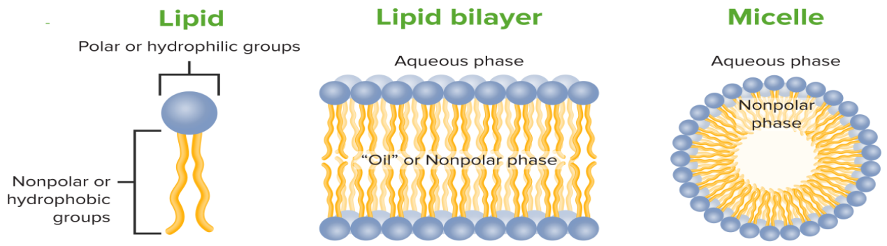
Figure 13. Lipids

- Head of Lipid has interaction with water molecules whereas tail does not..
- Non Polar come together to form a spherical or other structure as seen in figure 13.

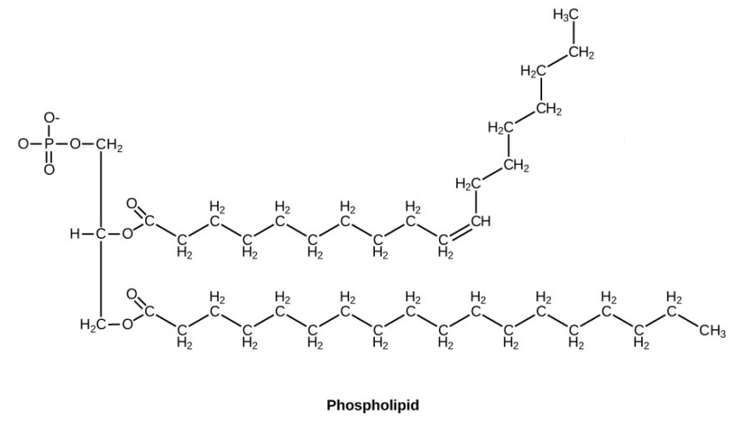
Figure 14. Phospholipid (head)

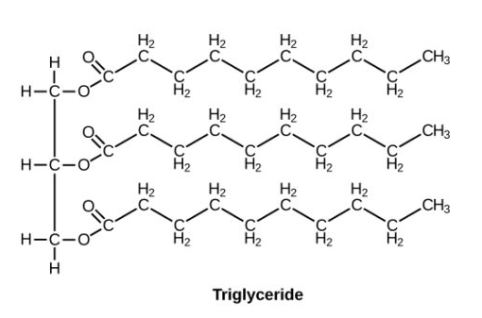
Figure 15. Triglyceride (tail)

PROPERTIES AND FUNCTIONS OF CARBOHYDRATES

Properties

- Chemical Composition:

- Composition: They are organic compounds.
They are composed of Carbon, Hydrogen & Oxygen atoms in the ratio 1:2:1 respectively.
Carbon molecules are hydrophilic.

- Monomers: These are basic building blocks of Carbohydrates. They are constructed from monosaccharides such as glucose & fructose.

- Solubility:

- Water Solubility: Most carbohydrates are highly soluble in water due carbohydrates having functional group called hydroxyl group. They are hydrophilic in nature.

- Classification:

- Simple and Complex: Carbohydrates are classified into simple sugars (monosaccharides and disaccharides) Ex- Glucose or into complex carbohydrates (polysaccharides ) Ex- Glycogen .

- Dietry fibre:

- They also act as dietry fibre. Carbohydrates have bonds between its molecules called Glycosedic bond.

Functions

- Energy Source :

- Primary Role : Carbohydrates serve as a primary source of energy for living organisms.

- Conversion : Monosaccharides (particularly Glucose) are broken down through the process called cellular respiration which generates ATP.
- ATP’s are the universal energy currency of cells. They power the essential actions like muscle contraction.

- Energy Storage:

- Glycogen (in Animals): Excess glucose is stored in the form of glycogen in animals, primarily in the liver and muscles.
- If energy is required by body Glucogen can be broken down to form glucose.

- Starch (in Plants): Plants store surplus glucose as starch in various plant tissues like seeds and fruits, which serve as energy reserve.

- Structural Support:

- Cellulose (in Plants): These are complex Carbohydrates. They contribute to provide structural rigidity (plants stand straight and maintain their shape).
- They provide structural support to plant cell walls through the formation of cellulose

- Transport of Energy:

- Sucrose : Carbohydrates like sucrose facilitate the transport of energy in the form of sugars within plants.
- It is synthesized in leaves & then transported in plants to provide energy to plants.

- Quick Energy Release:

- Glucose: It is readily available energy. Rapid breakdown of glucose (through cellular respiration) provides quick energy for cellular processes.

- Metabolic Regulation:

- Blood Sugar Regulation: Carbohydrates play a vital role in regulating blood sugar levels by controlling release of glucose in blood, ensuring a steady energy supply.
- Fibres also help in regulating blood sugar levels.

PROPERTIES AND FUNCTIONS OF NUCLEIC ACIDS (Biomolecules)

Properties

- Sequence Specificity:

- The sequence of nitrogenous bases (AGTC) along the nucleic acid chain is specific and carries genetic information and code.
- Any small change in Nitrogen base, alters the entire genetic code.

- Double Helix (DNA):

- DNA has a double-helix structure, where two strands wind around each other to represent a twisted ladder structure.
- Hydrogen bonds are present between complimentary base pairs. ( A--> T , G--> C)

- Single-Stranded (RNA):

- RNA is usually single stranded, with various types like messenger- mRNA, transfer- tRNA, and ribosomal- rRNA.
- mRNA- Carries genetic information from DNA to Ribosome. Based on the genetic code amino acids convert to Protein & Protein synthesis occurs.
- tRNA- It delivers the amino acid to Ribosome where mRNA is waiting for protein synthesis.
- rRNA- It forms the structure of Ribosome which actually synthesizes the Protein.

- Genetic Code:

- Nucleic acids encode the genetic information.
- These acids determines the traits and characteristics of living organisms.
- It decides how organism functions.

- Complementary Base Pairing:

- In DNA, Adenine pairs with Thymine, and Guanine pairs with Cytosine, forming complementary base pairs.
- Holds 2 strands together.
- Helps in copying of Genetic Information during cell division.

- Role in Protein Synthesis:

- Protein are essential for various functions.
- DNA stores the code for protein synthesis.
- Nucleic acids facilitate protein synthesis by carrying and translating genetic instructions.

- Essential for Heredity:

- Nucleic acids (particularly DNA) are vital for the inheritance of genetic traits from one generation to the next.

- Cellular Regulation:

- Nucleic Acids participate in regulating cellular processes, gene expression, and controlling various metabolic activities. Done by controlling Genes ON and OFF at particular time.

Functions

- Genetic Information Storage:

- Nucleic acids, particularly DNA, store and carry genetic information that dictates the hereditary characteristics of living organisms.
- DNA is a master molecule, that acts as a secure storage device for genetic information, that defines an organism.

- Protein Synthesis:

- Nucleic acids (NA) are instruments for protection of proteins.
- NA do this through the process of transcription (genetic code in DNA is separated to form mRNA) and translation ( process of the Amino acids going to rRNA and protein synthesized), play a crucial role in the synthesis of proteins. These are the building blocks of cells

- Cellular Regulation:

- They participate in the regulation of various cellular processes ( Differentiation ).
- NA regulate gene expression influencing the overall functioning of cells.

- Hereditary Transmission:

- Nucleic acids are responsible for transmitting hereditary traits from parents to offspring, ensuring the continuity of genetic information.
- Replication of DNA is involved here.

- Transfer of Genetic Code:

- mRNA, a type of nucleic acid, carries the genetic code from DNA to the ribosomes, where protein synthesis occurs.
- mRNA bridges gap between DNA and Ribosomes.

- Enzymatic Activities:

- Some nucleic acids, like ribozymes, exhibit enzymatic activities, participating in biochemical reactions within cells.

- Energy Transfer:

- Nucleic acids contribute to the transfer and storage of energy in the form of Adenosine Tri Phosphate (ATP).
- ATP is a molecule crucial for cellular energy transfer.

- Cellular Signaling:

- Certain nucleic acids are involved in cellular signaling pathways, influencing responses to external stimuli and environmental changes.

- Maintenance of Cell Structure:

- Nucleic acids contribute to the maintenance and integrity of cell structures, influencing cell division and growth.

- Synthesis of Biomolecules:

- They are involved in the synthesis of various biomolecules, contributing to the overall structure and function of living organisms.

PROPERTIES and FUNCTIONS OF Proteins

Properties

- Structure:

- Proteins exhibit a complex three-dimensional structure determined by their amino acid sequence.
- Properties and Shape of proteins is determined by arrangement of Amino acids.
- They have primary, secondary (alpha helix structure, beta sheet structure), tertiary, and quarternary structural levels.
- Structure is crucial for protein functions.

- Amino Acid Composition:

- Proteins are composed of amino acids linked by peptide bonds.
- The specific arrangement of amino acids dictates the protein's structure and function.
- These may contain heterophilic/ hydrophobic, structure (combination) of compounds.

- Solubility:

- Proteins can vary in solubility, with some being soluble in water (hydrophilic) and others in lipids (hydrophobic).
- This feature determines how they work in a cell.

- Denaturation:

- Proteins can undergo denaturation ( lose its shape or property or functions (de-natured) ) due to factors like heat, pH changes, or chemicals, resulting in loss of structure and function.

- Specificity:

- Proteins exhibit specificity in their interactions with other molecules.
- Each type is designed for a particular function or molecular interaction.

- Biological Functions:

- Proteins serve diverse biological roles, including enzymes.
- Enzymes catalyze chemical reactions in body, antibodies for immune response, and structural proteins for support that move molecules in body.

- Flexibility:

- Proteins can change their conformation to adapt to different biological environments and perform their functions more effectively.

- Binding and Recognition:

- Proteins can bind to other molecules, facilitating cellular processes such as communication, signaling and transport.

- Catalytic Activity:

- Many proteins act as enzymes, accelerating biochemical reactions within cells

- Diversity:

- The diversity of proteins allows them to carry out a wide range of functions critical to cellular life.
- Each protein has different/ unique function.

Functions

- Enzymatic Activity:

- Example: Catalase is an enzyme that catalyzes the breakdown of hydrogen peroxide into water and oxygen.

- Structural Support:

- Example: Collagen (structural protein) provides structural support to connective tissues in skin, bones, and tendons.

- Transportation:

- Example: Hemoglobin transports oxygen molecules from the lungs to tissues and carries carbon dioxide back to the lungs.

- Defense and Immunity:

- Example: Antibodies defend against pathogens by recognizing and neutralizing foreign substances.

- Cell Signaling:

- Example: Insulin is a signaling protein that regulates glucose uptake by cells.

- Motion and Contraction:

- Example: Actin (gives direction of contraction/ movement) and myosin (contracts/ relaxes based on directions) are proteins involved in muscle contraction and cell movement.
- They work together as intricate machine generating force.

- Hormonal Regulation:

- Example: Insulin and glucagon (helps in release of glucose to blood when blood sugar levels reduce) are hormones (protein) that regulate blood sugar levels.

- Storage of Molecules:

- Example: Ferritin stores iron in a soluble and non-toxic form within cells & ensures its readily availability for transport of molecules.

- Catalysis of Metabolic Reactions:

- Example: Lipase is an enzyme that acts as catalyzes and breakdown lipids during digestion.

- Regulation of Gene Expression:

- Example: Transcription factors are proteins that regulate the expression of genes during protein synthesis.

- Sensory Response:

- Example: Rhodopsin is a light-sensitive protein involved in vision.

- Blood Clotting:

- Example: Fibrinogen is a protein involved in the blood clotting cascade.

- Buffering and pH Regulation:

- Example: Hemoglobin helps maintain the pH balance in red blood cells.

- Energy Source:

- Example: In starvation, proteins can be broken down into amino acids for energy production.

